Solutions to Exercises from Absorption Chillers and Heat Pumps

# Chapter 3

## 3.1. Derive equations 3.20 and 3.21 from 3.19.

Let us follow the math. Based on the total mass, we must have

We will need a conversion from mole quantities to mass fraction. This is obvious:

Now we can start differentiating. First let us observe that

Note that partial molal Gibbs free energy in equation 3.19 should be denoted with an overbar, and deriving partial mass quantities requires the equations shown in example 3.1. So we have

And similarly

## 3.2. Evaluating chemical potential of NH3 in mixture with water.

We follow Example 3.1. However, note that using a fundamentalgleichung, er, equation of state as discussed in section 3.1.3, it may not be necessary to compute a numerical derivative, if an analytic derivative exists.

To proceed using open software, we now need to implement the mixture properties. The IAPWS offers a formulation and guidelines in [1], based on Tillner-Roth and Friend [2]. These require also an implementation of IAPWS pure water properties, which have already been implemented in an open manner by a number of projects.

Meanwhile, an alternative is to borrow some existing properties from EES’s external library, NH3H2O, or REFPROP9. Here are some outputs. Here, is for ammonia, for water. As can be seen, although the mass fraction is quite different, the chemical potentials are very similar at both points, which are in equilibrium. There difference is probably due to the numerics at the saturated vapor point, because the forward difference method used to evaluate fetches a superheated state. Reducing the quality of the second point to 0.999 brings the potentials into very close agreement.

|  |  |  |  |  |  |  |  |  |
| --- | --- | --- | --- | --- | --- | --- | --- | --- |
|  | T | P | x | h | s | u | v | Qu |
|  | K | bar |  | kJ/kg | kJ/kg-K | kJ/kg | m^3/kg |  |
| sat liquid | 373.15 | 10.00 | 0.31568 | 240.46 | 1.2693 | 239.2 | 0.00122 | 0.0000 |
| sat vapor | 373.15 | 10.00 | 0.92988 | 1563.20 | 5.1263 | 1391.5 | 0.17168 | 1.0000 |
| almost sat vapor | 373.15 | 10.00 | 0.92926 | 1561.88 | 5.1224 | 1390.4 | 0.17151 | 0.9990 |
|  |  |  |  |  |  |  |  |  |
|  | g | dgdx | mu1 | mu2 |  |  |  |  |
|  | kJ/kg | kJ/kg | kJ/kg | kJ/kg |  |  |  |  |
| sat liquid | -233.18 | -189.683 | -362.983 | -173.301 |  |  |  |  |
| sat vapor | -349.68 | -195.733 | -363.408 | -167.674 |  |  |  |  |
| almost sat vapor | -349.57 | -189.683 | -362.983 | -173.301 |  |  |  |  |

## 3.3. Evaluating chemical potential of H2O in mixture with ammonia.

See previous.

## 3.4. Properties as mole fraction.

Not really useful, but we need to derive equation 3.51 anyway. First derive equation 3.50. From equation 3.14,

Now, assuming an ideal gas model, is constant and , so

Integrating,

The first equality in equations 3.51 can be assumed (as definition of partial entropies). Partial pressures are given by Dalton’s law, and . Then expanding the pressure terms shows how to obtain the second equality and definition of :

## 3.5. Expression for mixture molecular weight (trivial).

a. This is given in example 3.1 as

b. Equation 3.53 (also used in example 3.1, just renaming ) converts from mass fraction to mole fraction and makes it clear that

## 3.6. Mixture Enthalpy

|  |
| --- |
| (a) Mixture properties from TPx: NH3H2O  State(T=323.15, P=10.0, x=1e-08, h=210.3444081126644, s=0.7066350873326258, u=209.33622616490044, v=0.0010081819477639738, Qu=-0.001)  ['K', 'bar', ' ', 'kJ/kg', 'kJ/kg-K', 'kJ/kg', 'm^3/kg', ' '] (b) ... in molar units: Meff = 18.0149999896 kg/kmol  hbar = 3789.35450996 kJ/kmol  (c) Partial component enthalpies  State3(dhdx=-645.5897376451958, h1=-435.245323076634, h2=210.34441456856177) kJ/kg (d) Enthalpy of mixing h_ideal = 210.344419605 kJ/kg, h_mix = -1.1492019695e-05 kJ/kg (e) ... in molar units h1bar = -7412.66309732 kJ/kmol  h2bar = 3789.35462845 kJ/kmol (f) ... in molar units h_mix_bar = -0.000207028734685 kJ/kmol |

## 3.7 Aqueous lithium bromide along a saturated isotherm

To understand the comment, we must realize the implicit assumption in the chapter. Explicitly, it is that lithium bromide remains in solution, so that vapor in a lithium bromide and water mixture is only water. Then recall that to maintain equilibrium between two phases, pressure, temperature, and chemical potential must match (equations 3.58 to 3.60). Let’s call the water component 2. So these two requirements give:

Then our assumption means that the chemical potential of the single component phase is given by the Gibbs free energy. Next, to apply Gibbs-Duhem, start with its representation as equation 3.24:

Now can be computed from property lookups both for the liquid aqueous lithium bromide and for the water vapor. So to compute the chemical potential of lithium bromide component, rearrange as

For fun let’s also compute some values.

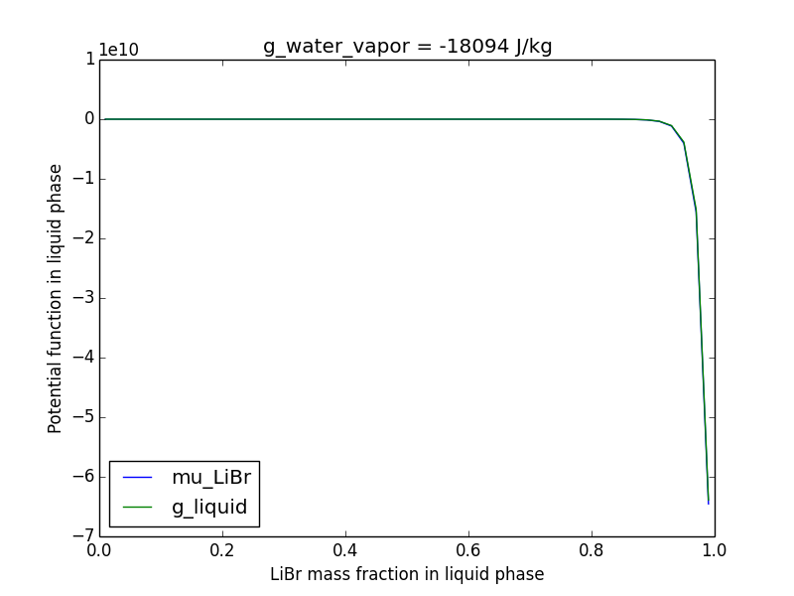

## 3.8 Specific heats at constant pressure

The requested function is already included in the available library functions for aqueous lithium bromide. For ammonia-water mixtures, it is simplest to use the form of equation 3.44 directly. We can use a simple forward difference formula for the derivative wrt temperature.

## 3.9. Evaluate exercise 3.7

First identify which mass fraction corresponds to this pressure, then use existing routines.

|  |
| --- |
| T,P = 323.15 K, 0.04 bar  ->  g_water_vapor = -18093.9961436 J/kg,  x = 0.483419892307, g_liquid = -14883.1983558 J/kg,  mu_libr = -11452.1557087 J/kg |

Again, by equation 3.58, the chemical potential in the vapor phase must be the same, despite that there is no LiBr present in that phase.

## 3.10. Evaluate exercise 3.7

Aha, a trick question! Knowing the chemical potential of water is how we solved the problem.

## 3.11. Thermodynamic consistency

Since the integration is path-dependent, instead it is better to look at the residuals wrt one variable at a time. Then inconsistency can be viewed as a two-valued function of state space. Eg, with dT = 0, evaluate

### a. Ammonia-water at 100 deg C, 10 bar, and 0.5 mass fraction to 120 deg C, 11 bar, and 0.5 mass fraction.

The second residual is guaranteed to be zero for ammonia water mixtures using the library function that computes specific heat numerically from enthalpy.

### b. Aqueous lithium bromide from 100 deg C, 1 kPa, 0.6 mass fraction LiBr to 120 deg C, 2 kPa, 0.6 mass fraction.

Some results

## 3.12 Enthalpy-mass fraction for water/LiBr (cf fig 3.10)

Some results

## 3.13 Pressure-temperature-mass fraction for water/LiBr (cf fig 3.18)

Some results

## 3.14 Enthalpy-mass fraction for ammonia/water (cf fig 3.11)

Some results

## 3.15 Pressure-temperature-mass fraction for ammonia/water (cf fig. 3.19)

Some results

## 3.16 Custom exercise: Derive eqn 3.33

Some results

## 3.17 Custom exercise: Derive eqn 3.51 (see answer for exercise 3.4)

Some results